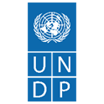


Transformative Economic Policy Programme (TEPP)
Quarterly Project Progress Report
January-March 2025

Contents

Project Brief 2
Executive Summary 3
1. Progress and Results 4
Output 1: Trade Policy and Negotiation Capacity Strengthened 4
Output 2 - Government institutional structures on trade policy assessed to improve effectiveness and coordination 5
Output 3: Engagement with the private sector improved through regular consultation on business and trade policies and investment climate 6
Output 4: New research and evidence generated to support effective economic policy-making and institutional reforms 7
2. Project Management 9
3. Lessons Learned 10
4. Milestones for Quarter II (April- June 2025) 11
5. Visibility and Communication 11
6. Value for Money (VfM) 14
Annex 16
Project Risk Register 18
18

Project Brief
Implementing Agency | United Nations Development Programme (UNDP)
Country | Bangladesh
Project title | Transformative Economic Policy Programme (TEPP)
Project duration | July 2024 – March 2028
Reporting Period | January- March 2025
Project budget for this financial year (January-December 2025) | USD 1,482,000, equivalent GBP 1,132,248.00
Total project budget | GBP 4,000,000
Lead department for the project | Democratic Governance Cluster
Date this report is submitted: | April 30, 2025

Executive Summary
The Initiation Plan (IP) for the Transformative Economic Policy Programme (TEPP) was formally rolled out on July 1, 2024. The United Nations Development Programme (UNDP) is implementing the project with the Foreign, Commonwealth, and Development Office (FCDO) and in partnership with the Ministry of Commerce (MoC) and the Bangladesh Investment Development Authority (BIDA). The project aims to assist Bangladesh in transitioning from the group of Least Developed Countries (LDCs). The key areas of this assistance include improving trade policy, export competitiveness, domestic productive capabilities, and creating a more conducive environment for domestic and foreign investments.
In the reporting period between January and March 2025, the project built on the momentum created in the last quarter of 2024. There was a period of political crisis and social unrest immediately after the TEPP was started. But starting from Quarter 4 of last year, the implementation has picked up speed. Several activities were initiated to support, among others, an institutional framework for enhancing national capacities in trade negotiations, trade policy, and improving the business investment environment in Bangladesh. Analytical work included identifying critical bottlenecks and opportunities in potential growth sectors of the economy to inform the investment strategy.
MoC formally endorsed the terms of reference (TOR) for a Trade Negotiators Pool. A Working Committee was established to oversee the rollout of this initiative. Following consultations among the Working Committee members, the training module for the introductory course is being developed. In parallel, an institutional diagnosis of the Bangladesh Competition Commission (BCC) was conducted. Using a structured methodology, the diagnostic covers areas such as the regulatory framework and operational efficiency of BCC. The findings and the recommended action plan will be presented at a high-level forum in May 2025. The methodology used in this diagnosis can become the template for similar assessments across MoC and BIDA. This, in turn, will help to better target capacity gaps and measure improvements systematically.
In addition to assistance provided to MoC on trade negotiations, TEPP is also conducting selective analytical work to inform the national discourse and strategies on LDC graduation. Besides that, TEPP staff are actively involved in consultations in various forums on LDC graduation. While formal LDC graduation is an important milestone for the country, there is a lot of anxiety about the readiness of Bangladesh, especially the impact of the loss of preferential treatment, including tariff-free access to several countries. It is important to note that trade is not simply a matter of commercial transactions across the borders or within the country.
Building export competitiveness requires carefully crafted trade agreements, as well as domestic productive capabilities of the private sector, necessary capital investments, and hard and soft infrastructure. Moreover, for a developing country like Bangladesh that relies heavily on import tariffs, deregulation and the rationalization of such tariffs require engagement with a wide range of institutions. Needless to say, many of these areas are interconnected. In light of this, the role of MoC must further evolve to ensure proper coordination and the conveying of relevant stakeholders. The project is positioning itself to offer assistance to MoC to adapt and respond effectively to its evolving function in the government.
In the meantime, the role of the Research and Analysis Unit (RAU) that the project has set up in BIDA is being further strengthened. The aim is to embed RAU in BIDA to help improve its business intelligence capabilities, effectively track policy actions, and facilitate investment promotion. To bolster investments, the project provided financial and technical support to BIDA for organizing the Bangladesh Investment Summit 2025. Leveraging the funding, the project also helped in raising contributions from the private sector for hosting this summit. BIS is expected to attract over 3,000 participants across the globe. BIS will have breakout sessions that TEPP is helping to co-design. Moreover, visits to special economic zones (SEZs) have been organized for businesses to assess opportunities for investing in Bangladesh. The summit will help to strengthen engagement between domestic businesses and international investors. One of the main attractions of the BIS is a fair at which youth-owned start-ups can showcase their businesses and make pitches to investors. A letter of intent (LoI) will be signed between UNDP, ILO, MoC and BIDA to develop a platform for promoting ethical investments and trade that can not only help the country to grow faster but also adhere to environment, social, and governance (ESG) standards. Meeting these requirements are essential for Bangladesh to ensure trade competitiveness and green transition.
Highlights Quarter 4
- Institutional capacity assessment and strengthening trade negotiation capacity, including creating a Working Committee.
- Strategic planning for embedding the Research and Analytics Unit (RAU) in BIDA
- Support in organizing the Bangladesh Investment Summit 2025
- Evidence-based research and advocacy informing policies concerning LDC graduation, trade competitiveness, and investment climate
- Partnerships to broaden the interface with and support for the private sector in Bangladesh.

1. Progress and Results

Output 1: Trade Policy and Negotiation Capacity Strengthened
As a Least Developed Country (LDC), Bangladesh has benefited from trade preferences from most of its trading partners. This has made it possible for the country to maintain competitiveness in readymade garments (RMGs), a sector which has increasingly seen thinner margins as the competition from other developing economies intensified. A concentration of its RMGs to a few selected economies also makes it difficult for Bangladesh. Bangladesh has a handful of free trade agreements (FTAs), while Vietnam, a close competitor, has 17 FTAs. With LDC graduation approaching, the country must engage in bilateral and regional negotiations to develop favourable trade agreements. Such agreements will allow Bangladesh to diversify its trade destinations and further stimulate demand for exports.
MoC has agreed to create a 50-member pool of experts for trade policy and negotiations. The members of this pool will come from key government ministries, think tanks, legal professionals, and business associations. An indicative capacity development plan has been developed for the trade negotiators' pool. The pool will receive technical support, including attending workshops, training courses, and study visits. The members will include a mix of junior, mid-level, and senior officials to ensure long-term capacity and institutional support.
During the reporting period, the first meeting of the Working Committee (WC) was held that was chaired by the Additional Secretary (Export Wing), MoC. The discussions revolved around the profile and selection of members, type and duration of trainings, development of training curriculum, etc. At present, TEPP is developing an introductory training course for the trade negotiators pool. After nominations are received, the first training will be organized. Having a team of skilled professionals capable of navigating the complexities of international trade negotiations is critical for Bangladesh’s smooth LDC graduation. As Bangladesh transitions to a higher-tariff regime and engages in reciprocal trade agreements, the pool will enhance national capacity to negotiate effectively, protect trade interests, and comply with evolving global standards. In an evolving global landscape, achieving good terms while negotiating trade agreements can help Bangladesh better position itself in global supply chains. A pool of experts can also improve the formulation of trade policies and the execution of these policies. By ensuring diverse stakeholder representation, the pool will promote more inclusive and well-informed trade policy decisions aligned with post-LDC requirements. Once the pool members are finalized, the project team will consult with them to further develop the full training curricula that are context-specific and customized to the capacity needs of the members.

Potential impact of enhanced capacities in trade negotiations
Negotiate effectively in international trade forums
Strengthen the institutional capability
Better trade policy formulation
Export competitiveness and growth
Participation and representation of diverse stakeholders in trade policy discussion

Output 2 - Government institutional structures on trade policy assessed to improve effectiveness and coordination
The MoC leads the development of the country's trade policy, but its implementation relies on coordination with several other ministries and agencies, such as those responsible for standards, labor, the environment, and investment. This complexity underscores the necessity for enhanced inter-ministerial coordination, a role that the MoC must increasingly take on. Current mechanisms for such coordination are weak. Bangladesh's institutional trade policy framework was established during a time when the country enjoyed numerous preferences and regulatory compliance was less stringent.
As the country prepares for graduation from the LDCs, it needs to reform tariff and subsidy systems, enhance intellectual property protection, and comply with environmental, social, and governance (ESG) standards. To support these efforts, the project is exploring expanding partnerships by establishing a knowledge-sharing platform and creating an interface with the private sector. Meanwhile, the project is also working on disseminating the Export Policy 2024-2027. With support from TEPP, this policy is being translated from Bangla to English. An English version of this document will help international stakeholders—such as investors, trade partners, and development agencies—better understand Bangladesh’s export priorities and policy direction.
During the reporting period, TEPP conducted an institutional diagnostic of the Bangladesh Competition Commission (BCC). Persistent concerns about anti-competitive practices, price manipulation, and market distortions—particularly against the backdrop of sustained inflationary pressure and growing market concentration—have brought the issue of competition regulation in Bangladesh into sharp focus. Despite significant economic growth over the past two decades, driven predominantly by private sector dynamism, questions remain as to whether such growth has been underpinned by a fair, transparent, and rules-based competitive environment that protects consumer welfare and ensures efficient resource allocation. The diagnostic will help in devising a plan of action for addressing systemic problems and transforming BCC into an effective regulatory institution, capable of actively promoting fair competition and safeguarding consumer welfare within Bangladesh. The draft report is complete and is currently being reviewed. There are also discussions ongoing to use a similar methodology for institutional assessment of MoC and, in the future, BIDA. Structured assessments not only help to deliver customized technical assistance, they also serve as the baseline for measuring change.
Setting up the Research and Analytics Unit (RAU) at the BIDA has been one of the key TEPP deliverables. However, RAU must be further embedded in BIDA so that it can become more responsive and play a more strategic role in gathering business intelligence. In this regard, TEPP appointed a Senior Investment Policy Advisor, who has been providing strategic guidance to the Executive Chairman of BIDA and working closely with RAU to make it function effectively. TEPP also organized an annual workplan meeting with BIDA to refine strategic priorities and identify interventions and to align them with ongoing economic reforms. In the meantime, RAU has been providing support to BIDA in revising the Investment Handbook. RAU also re-designed sector profiles, booklets, and brochures for BIDA that provide an overview of investment opportunities and the menu of BIDA’s services to investors.
Moreover, TEPP helped BIDA set up a national semiconductor task force. In the first quarter, significant progress was made in identifying priorities for the sector through feedback from the task force members. A roadmap with time-bound actions for the sector was prepared and presented to the taskforce in mid-March and their commitment was secured for implementing the roadmap. A draft concept note for a private sector advisory council was also prepared following a request from BIDA. A comprehensive mapping of the work permit process for foreign nationals and private investors in Bangladesh is currently being done. This is also one of BIDA's priorities for improving the business environment for investors. The mapping includes a review of the processes and associated costs, time taken, and the number of documents needed. The analysis will also include specific actions that BIDA and other agencies can take to simplify the process.
Furthermore, UNDP is in the process of finalizing a partnership agreement with UNCTAD. Starting from June of this year, UNCTAD will support BIDA to conduct an Investment Policy Review (IPR). It will review the progress that Bangladesh has made since 2013, when the last IPR was conducted. IPR will include a description of key FDI trends and policy changes, a summary of areas where important reforms took place, and identify key areas where further work is required. It will also include a way forward to identify reforms needed to further improve the investment environment and propose follow-up actions. Importantly, UNCTAD will help BIDA to create a “Live Implementation Matrix”, a tool that can help BIDA to record and review progress on major policy actions. Increasingly, countries are adopting this tool for business and investment policy reforms.

Output 3: Engagement with the private sector improved through regular consultation on business and trade policies and investment climate
TEPP is preparing to support the upcoming Investment Summit, which will feature multiple sessions across six key sectors: renewable energy, digital economy, textiles and apparel, healthcare and pharmaceuticals, and agro-processing. These sectors have been identified for their rapid growth potential and strategic importance. RAU staff have been actively participating in all preparatory meetings and are involved in key decision-making committees set up for venue management, logistics, catering, and other operational activities for the summit. The summit aims to highlight the evolving investment landscape in the country and promote opportunities for foreign direct investment (FDI). The specific objectives of the summit are:
- Position Bangladesh as a dynamic and competitive global investment destination.
- Highlight recent reforms and policy initiatives to promote ease of doing business.
- Showcase sector-specific investment opportunities, particularly in Special Economic Zones (SEZs) and emerging industries.
- Facilitate dialogue and partnerships between investors, policymakers, and development partners.
- Promote sustainable and inclusive investments aligned with national development priorities and the Sustainable Development Goals (SDGs).
The TEPP team has developed a questionnaire to collect insights from youth entrepreneurs who will attend a Youth Expo organized by UNDP’s Futurenation. Based on this survey, RAU will prepare a policy brief that will highlight the challenges faced by entrepreneurs and the necessary policy changes to support youth entrepreneurs in Bangladesh.
MoC serves as the main liaison with the private sector and other stakeholders regarding international trade and LDC graduation. However, this function must be further strengthened. TEPP is already helping MoC to reach out to stakeholders and actively consult with them on a range of policy issues. In the coming months, TEPP will continue to facilitate dialogue on trade barriers, the investment climate, labour and product standards, export incentives, and small and medium enterprises (SMEs). In the present quarter, TEPP has already tried to promote the journey of women-owned SMEs through video testimonies. These were done in conjunction with sector assessments on the IT, leather, jute, and eco-friendly product sectors. These videos were shared across different social media platforms.
There were also consultations with UN agencies and development partners ahead of the Bangladesh Investment Summit 2025, exploring collaboration in developing a sustainable and inclusive trade and investment ecosystem. This resulted agreement to sign a Letter of Intent (LoI) between UNDP, ILO, BIDA, and MoC at the Summit. Under this agreement, BIDA and MoC aim to organize an annual forum and provide services to businesses. ILO and UNDP are committed to facilitating an online portal, hosted by BIDA, to support best practices and programs on decent work, human development approaches in trade and investments, International Labour Standards, responsible business conduct, and ESG principles in businesses.

Output 4: New research and evidence generated to support effective economic policy-making and institutional reforms
Bangladesh must proactively engage with trade partners to secure favourable terms following its graduation from the LDCs. High-quality, timely policy research will support these efforts by generating evidence that guides trade negotiations, influences policymakers, and informs strategies for improving the investment climate, trade preferences, and inclusive economic outcomes. The project prioritizes research that adds value, avoids duplication, and is action-oriented. Currently, the project is conducting research in the following areas to identify bottlenecks, provide concrete recommendations, and, if feasible, test solutions.
Agricultural Machinery
Bangladesh has seen the size of its industrial and services sector grow. Although its relative contribution to GDP has declined, the agriculture sector still presents significant investment opportunities. To sustain agricultural production, there is a need for increased mechanization of farm activities. Agricultural productivity is essential to meet the rising food demand driven by rapid urbanization and income growth, thereby creating a market for agricultural equipment in Bangladesh. The study aims to find the investment potential of agricultural equipment. It conducts a comparative assessment of the domestic sector against competing countries, identifies opportunities for agricultural machinery, and proposes policies to enhance investment in agricultural equipment in Bangladesh. This policy paper has been reviewed by the relevant stakeholders and is currently in the process of being printed. Through strong advocacy, this study is expected to play a crucial role in promoting agricultural modernization.
Investment Diversification
TEPP conducted a research study in 2024 titled “Investment Diversification of Priority Sectors After LDC Graduation.” The policy paper is currently in the publication phase. The research findings were presented to relevant stakeholders on November 18, 2024. By identifying agro-processing, information technology (IT), IT-enabled services (ITES), and jute and jute products as priority sectors, the study provides a strategic roadmap for diversifying the economy beyond traditional exports, such as ready-made garments. This diversification is essential for building economic resilience, reducing vulnerability to sector-specific shocks, and ensuring sustained growth after the loss of preferential trade benefits. The paper aims to guide policymakers in directing investments, designing sector-specific incentives, and reforming regulatory frameworks to enhance competitiveness.
8th SANEM Annual Economists’ Conference 2025 (SAEC)
TEPP provided financial support for SAEC 2025, which was organized under the main theme “Restoring Stability in Economic and Political Landscapes: Navigating Fragility to Resilience.” The conference helped to foster critical dialogue, evidence-based research, and inclusive policy discussions in South Asia. Over three days, it featured seven high-level plenary panels, twenty thematic breakout sessions, and more than eighty academic papers from across the region. Based on the conference discussions, A policy paper titled “Trade and Investment in Turbulent Times: Bangladesh at a Crossroad,” was prepared that is currently under review.
Investing in Bangladesh’s Leather Industry: Challenges and Solutions”
This assessment is in the final stages. The draft is currently being reviewed, and once that is completed, the key findings will be shared at an event scheduled for the next quarter. The leather industry, which currently accounts for 4% of total exports and employs over 850,000 workers, can play a crucial role in this transition. However, it faces ongoing challenges, including environmental degradation, inadequate compliance with international standards, and limited investment, which hinder its growth. This paper examines the current landscape of the sector, identifies barriers to progress, and proposes actionable solutions to align its development with the Sustainable Development Goals (SDGs).
Technology Adoption of SMEs
Bangladesh's economic future is closely tied to its ability to remain competitive in the global export market following its graduation from LDCs. Adopting advanced technologies is essential for increasing production efficiency, reducing costs, and meeting global quality standards. However, sectors such as RMGs, ICT, and pharmaceuticals have not yet significantly adopted Industry 4.0 technologies, including automation, artificial intelligence (AI), and the Internet of Things (IoT). The study draws comparisons with countries like Vietnam and India, highlighting their rapid initiatives in technology adoption. The study aims to develop a roadmap that guides policymakers and industries to incorporate advanced technologies into their production and supply chains in a cost-effective way.

Tariffs and Revenue
The Terms of Reference (ToR) have been circulated for hiring an individual consultant to analyze the implications of tariff rationalization on revenue generation, business competitiveness, and economic growth. The consultant will seek insights from key informants, including policymakers, experts, the private sector, and other relevant stakeholders, in order to gain a better understanding of the changing policy landscape and the issues related to political economy.
Gender and trade
The Terms of Reference (ToR) have been published for hiring an individual consultant to analyze existing trade policies and their gender implications. The consultant will conduct a desk review, engage in consultations with the private sector and policymakers to validate findings and gather insights, and ultimately develop a 10-page policy brief. This brief will outline gender-sensitive trade policy recommendations aimed at enhancing women’s participation in export-oriented sectors following the graduation from LDCs.

2. Project Management
As of February 1, 2025, Dr. Mehruna Islam Chowdhury was made the interim Project Manager, succeeding Mr. Zubayer Hossen. The search for a new project manager is currently ongoing. A Communications Analyst has been hired and will begin in April. This position is essential for enhancing project visibility and managing knowledge. Several other recruitments are at an advanced stage, and it is anticipated that most of the positions will be filled in the next quarter. In the meantime, UNDP’s Country Economist is dedicating a significant portion of his time, providing technical advice and strategic oversight. Additionally, the UNDP Governance Cluster is giving the necessary backstopping for the project.
Expenditure Report
Currency | Annual Budget 2025  (January- December) | Expenditure  (January-March 2025) | Delivery Rate
US$ | USD1,482,000 | USD 197,926.37 | 13.35%
GBP | GBP1,132,248 | GBP 151,215.746 | 13.35%
UNORE: 1 USD = GBP 0.764
Challenges & Steps Taken

The project has faced challenges on multiple fronts, causing delays in the implementation of activities according to the work plan. There have been issues getting MoC fully engaged. MoC has been relatively slow in taking the idea of a trade negotiators pool forward. This has delayed related activities, such as organizing training sessions and hiring experts. Another major challenge has been the lack of effective coordination among various ministries and departments, underscoring the vital role the project can play in bridging these gaps. Given the current political context, there is some inertia and the government officials are not always very responsive. TEPP has continued to strengthen the lines of communication through regular emails and phone calls.

The recruitment process for hiring project staff has taken considerable time, impacting the project's smooth functioning. To address this, the UNDP Country Office has been engaging staff from other projects, such as deploying an interim Project Manager and allocating more time from the Senior Economic Advisor, to ensure the effective implementation of core activities. Additionally, the UNDP has actively deployed technical assistance from experts and project/research associates on short-term contracts to enhance the efficiency and quality of implementation. TEPP operates under an approved Annual Work Plan (AWP), which aligns with the overall programme document. Like all UNDP-supported projects, the AWP is finalized and approved at the beginning of each year in coordination with UNDP management. To ensure effective implementation, regular bi-monthly or quarterly review meetings are conducted with the project team, responsible cluster focal points, and UNDP management. These sessions focus on evaluating project activities and financial delivery against the latest progress reports.

As part of UNDP's risk-informed programming approach, a project risk assessment and mitigation plan is incorporated within the Annual Work Plan (AWP). In accordance with the UNDP Internal Control Framework (ICF), all staff roles and responsibilities are clearly defined, and segregation of duties is strictly maintained to ensure accountability and minimize fiduciary risk. For example, in the procurement and payment processes, initiation is carried out by designated procurement and finance focal points within the project. The Project Manager and the Cluster Programme Finance focal point ensure review and oversight. Final approval is granted by either the Cluster Programme Manager, Cluster Head, Operations Manager, or Deputy Resident Representative (DRR), in line with the Delegation of Authority (DoA) matrix. Additionally, following UNDP's financial and operational safeguards, the project adheres to the Harmonized Approach to Cash Transfers (HACT) to assess and manage the capacities of implementing partners, ensuring transparency and fiduciary compliance.

3. Lessons Learned
Lesson learned: A regular assessment of the needs and capacity of government partners can help realize the broader goals effectively.

The delivery of the project has been impacted by a challenging political environment. Shortly after the project's initiation, political turmoil led to the removal of the government. An Interim Government took office in early August 2024. Although the political situation has since stabilized, there have been significant personnel changes within government institutions, including the two key counterparts of TEPP. Building relationships and understanding the needs of national counterparts in this evolving environment required ongoing interactions between the project team and these counterparts. This effort is now yielding positive results, as greater trust and a stronger partnership have developed, contributing to increased momentum. During the first quarter of 2025, visible changes and a renewed sense of purpose were visible. Both BIDA and the MoC are increasingly seeking strategic advice and technical support from TEPP. A majority of activities remain aligned with the work plan, reflecting the programmatic goals that correspond with national priorities. Some milestones that faced challenges in the previous period have started to show progress. Regular coordination with key partners and assessment of government partners' needs helped accelerate project implementation in the reporting period. When national authorities recognize that project activities are aligned with their goals, they are more likely to support the achievement of project objectives.

To strengthen policy advocacy, it is crucial to develop partnerships with various government agencies instead of relying solely on one agency. TEPP has been collaborating extensively with MoC and BIDA. Given the cross-cutting nature of trade and investment issues, it could be beneficial for the project to expand partnerships or provide support to additional government counterparts, such as the National Board of Revenue (NBR) and the Ministry of Industries. Furthermore, to enhance private sector engagement in trade and investment policy formulation, the project must have regular consultations with the private sector and consider institutionalizing it. In light of LDC graduation, there are a range of areas where consultations with the private sector are critical to determine the readiness of Bangladesh. Besides improving competitiveness and productive capabilities, the private sector must mainstream labour standards, responsible business conduct, and ESGs.
Lesson learned: Broadening partnerships with other government institutions and further strengthening partnerships with the private sector is crucial for creating a lasting change.

4. Milestones for Quarter II (April- June 2025)
- Launch the introductory training for the 'Trade Negotiators' Pool'; this will be followed by designing an advanced training module and action plan.
- Further support RAU in positioning in BIDA as per the agreed strategy and work plan.
- Organize multistakeholder dialogues on research/studies, including:
(i) Leather sector supply chain, focusing on trade, investment, and sustainability;
(ii) Technology adoption in small and medium-sized enterprises (SMEs);
(iii) Policy on revenues and tariff rationalization.
- Initiate the Investment Policy Review and provide the necessary support to UNCAT and BIDA.
- Develop a work plan for private sector engagement and further explore the development of the collaborative platform following the signing of LoI and the private sector advisory council.

5. Visibility and Communication
During the reporting period, several workshops and consultations on trade and investment were organized. Additionally, various policy research projects and sector profiles were completed. The project also produced a four-episode video series to celebrate International Women’s Day. In all instances, the UK International logo was included on communication materials and publication cover pages in accordance with branding guidelines.
Stories of women SME entrepreneurs (International Women’s Day)
https://www.youtube.com/watch?v=mjtb44vcrFg
- https://www.youtube.com/watch?v=jGyDWRp5N5I
- https://www.youtube.com/watch?v=VfGwzUf9ahw
- https://www.youtube.com/watch?v=lMf3UAb1Tno

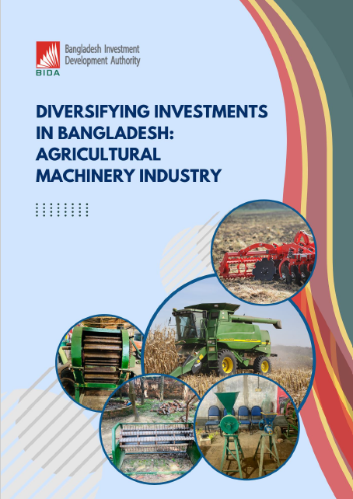
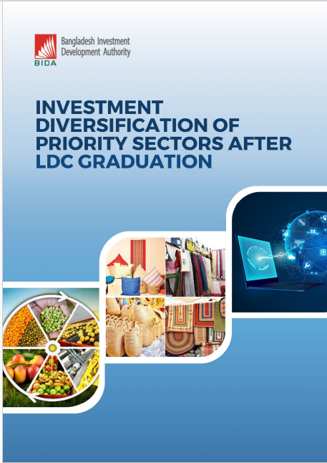

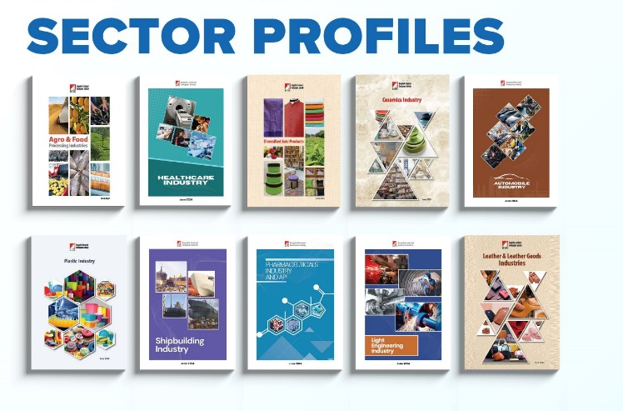

Success Stories of Women Entrepreneurs
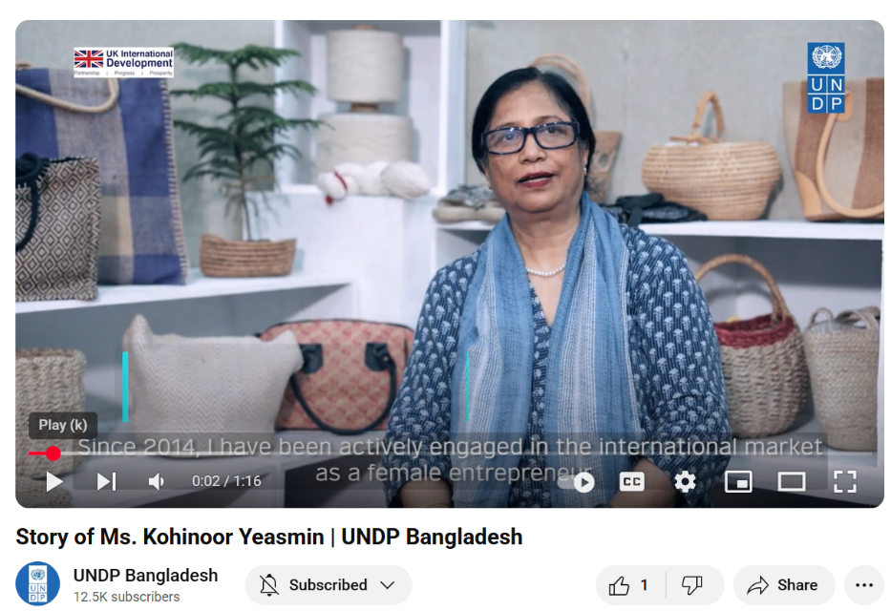
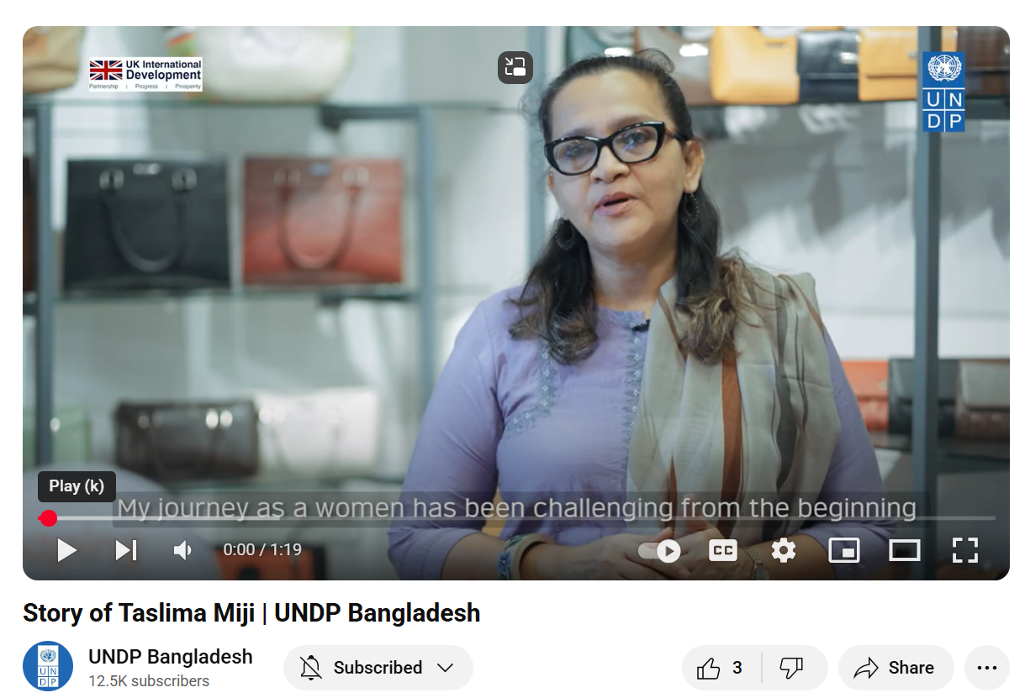

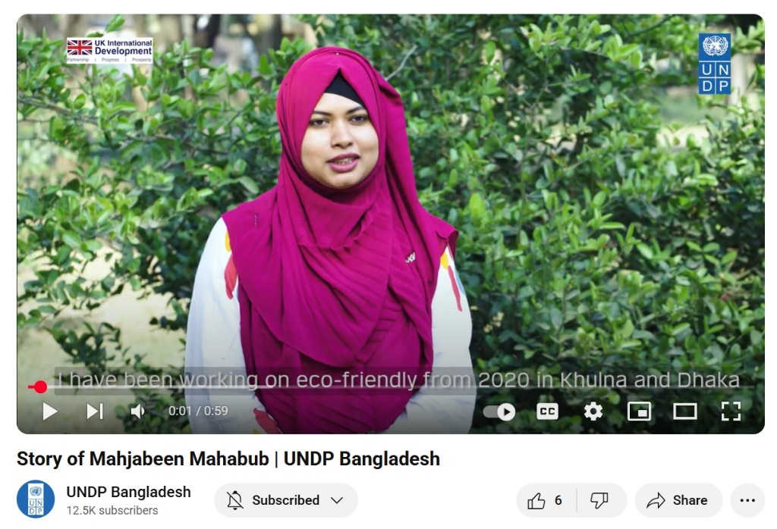
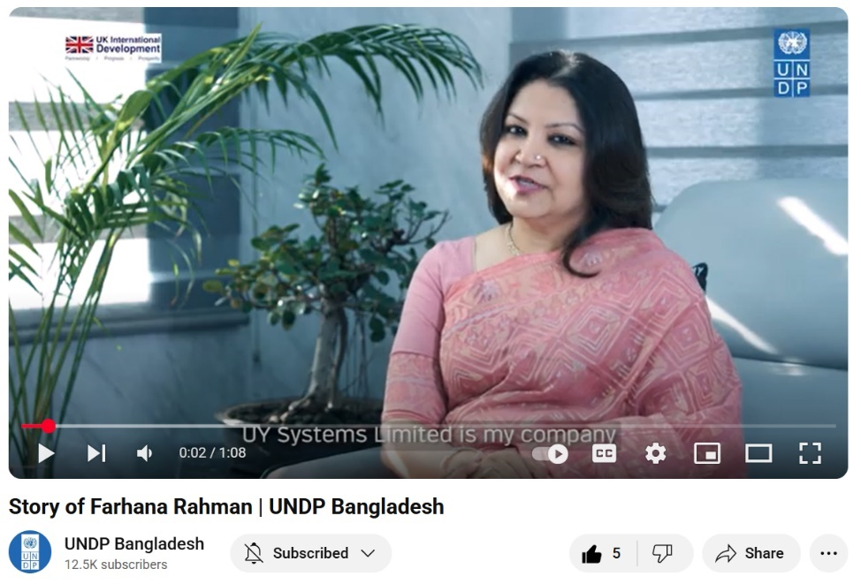

6. Value for Money (VfM)
During the reporting period of January to March 2025, the TEPP project maintained a strong focus on ensuring Value for Money (VfM) across its operations. Guided by the core principles of economy, efficiency, effectiveness, and equity, the project adopted a strategic and disciplined approach to resource utilization, delivering impactful outcomes while optimizing cost-efficiency.
Economy for Cost Saving
During each quarter. The project develops a procurement plan that is shared with the UNDP Country Office to avoid delays and unnecessary expenses. To ensure economy, all procurement and service delivery were conducted through a transparent and competitive process, with contracts awarded to the lowest qualified bidders. This approach balanced cost considerations with the overarching objectives of the project. However, it is ensured that quality and impact are not compromised while achieving substantial cost savings. In this context, expertise and prior engagements of the bidders are critically observed and evaluated through developing an evaluation panel during the procurement. The project also benefitted from UNDP’s core staff’s technical expertise on the economics and governance perspective. The project avoided leasing a separate office space and opted to share existing facilities with another UNDP project. This strategic decision helped reduce renovation expenses, equipment purchase costs, and recurring overheads.
Efficiency with a cost-effective Strategy
The project has been maintaining designed work plans for the implementation of activities efficiently. In line with promoting efficiency, the project has maximized the use of in-house resources for the design and implementation of critical studies. This not only reduced dependence on external consultants but also accelerated delivery timelines and built internal capacity. Conducting evidence-based and action-oriented research and reporting with the in-house resources can be considered a cost-effective strategy to strengthen the project’s policy advocacy framework. The project has also reduced recruiting time and personnel cost by hiring five UN Volunteers who are working in different important roles in the team.
The UNDP Country Office organizes workshops for project staff working on monitoring and evaluation, developing Terms of reference for recruitment and procurement processes, etc. Project staff currently supporting the M&E operations and procurement operations have been participating in these workshops and consulting with the relevant colleagues on a regular basis to gain efficiency in their work.
Gaining Effectiveness of the Desired Outcomes
The project has been setting clear targets and monitoring outputs and outcomes regularly. It demonstrated effectiveness by strategically supporting research and advocacy efforts that sparked public discourse and policy engagement. Notably, the study on inflation led to administrative action, with government stakeholders acknowledging the project's influence in shaping economic responses.
Furthermore, the investment diversification study stimulated robust national debate, signalling the timeliness and relevance of the project’s interventions. Through the study, the project has identified four potential sectors, on which further in-depth analytical work will be done for exploring bottlenecks that challenge their sustenance and policy level reforms will be identified for advocacy. Regular discussion with BIDA is being done to match their requirement with the project’s research activities to support investment policy making by evidence-based background analysis.
Ensuring Equity by Maintaining Inclusiveness
The project ensured equity by maintaining an inclusive approach to stakeholder engagement and by targeting policy reforms that address vulnerabilities within the current economic system. The focus on inflation and trade reflects concerns that affect diverse segments of the population, particularly low-income groups and small-scale producers. In this way the risks associated with inclusivity can be addressed in the later stage also.

Annex
Meeting Minutes
Working Committee Meeting on Trade Negotiators’ Pool

Ministry of Commerce, The Secretariat, Dhaka
16 March 2025
Attendees
Ministry of Commerce
- Md. Abdur Rahim Khan, Additional Secretary, Export Wing (Chair)
- Ms. Nahid Afroz, Joint Secretary (Export 2),
Foreign, Commonwealth and Development Office (FCDO), British High Commission
- Mr. Issam Mosaddeq, Economic Adviser
- Ms. Shamaila Mahbub, Programme Manager
UNDP
- Mr. Owais Parray, Country Economic Advisor
- Mr. Tanvir Mahmud, Senior Governance Specialist, Democratic Governance Cluster
- Dr. Mehruna Islam Chowdhury, Project Manager (a.i), TEPP II & Business and Human Rights National Specialist
Actions Agreed
- A 'Trade Negotiator Expert Platform (TEP)' will be established to act as the Secretariat under the Ministry of Commerce (MoC) to sustain trade negotiation efforts. A mid-level official, equivalent to a Joint Secretary (JS), will be designated from the MoC to oversee this platform. The TEP will maintain a database to record the registered members of the pool. The United Nations Development Programme (UNDP) will provide technical support for this platform as part of the TEP Project.
- UNDP will share draft minutes and application forms to nominate pool members from the relevant ministries, departments, and organizations. The nomination criteria will include a minimum of three years of work experience in trade-related issues, motivations, along with a relevant academic background in economics, trade, finance, development, commerce, or law. Exceptions may be made for candidates who demonstrate strong motivation or career aspirations to work in this area. A committee will review and approve the final nomination.
- The MoC will send a letter to the relevant ministries, departments, and organizations requesting that they nominate four participants (at the level of Deputy or Joint Secretary, including at least one female official) for the Expert Pool (EP). From these four nominated officials, the committee will select two to join the pool.
- The residential training workshop for the EP members will be organized in two groups, each consisting of 25 participants. Each group will include eight officials from the MoC, twelve officials from other ministries, and five members from the private sector. The training will last for five days.
- The Working Committee (WC) will approve the training modules and trainers. After the initial residential training workshop, ten members from each group will be selected for overseas training. One or two mentors from the MoC at the additional secretary level will serve as mentor. UNDP will provide logistical and technical support for the TEP training, and certificates will be issued upon completion.
Additionally, day-long and online training courses on various topics can be organized under the platform. To keep the platform dynamic and relevant, brainstorming sessions with resource persons can be arranged to conduct these sessions.

Project Risk Register
